FINAL USECASE DESCRIPTION

# home_w.png

# MAGIC ESTATE

# Project By:

# Gaurav Gaikwad

# Use Case #1: Sign up Account

## After hitting the sign in button press the sign up button on the sign in window. After this just fill the form just creates the account. After this just sign in as the user you just created.

USERNAME: mjord

PASSWORD: jordan

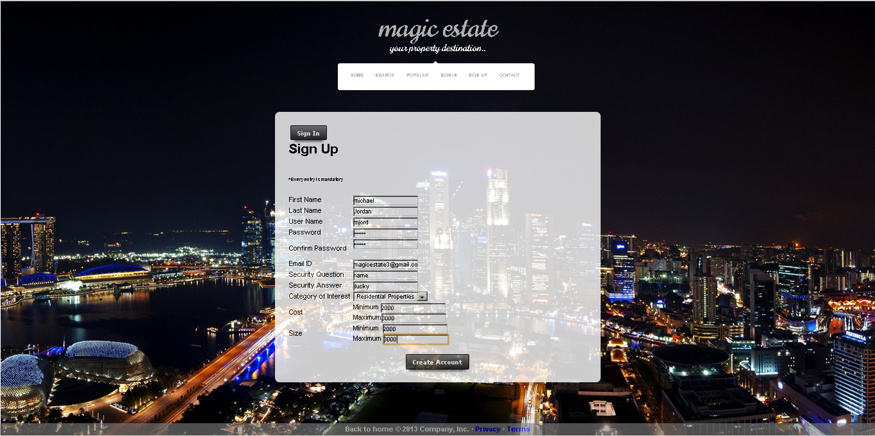

**Now sign in as user mjord**

case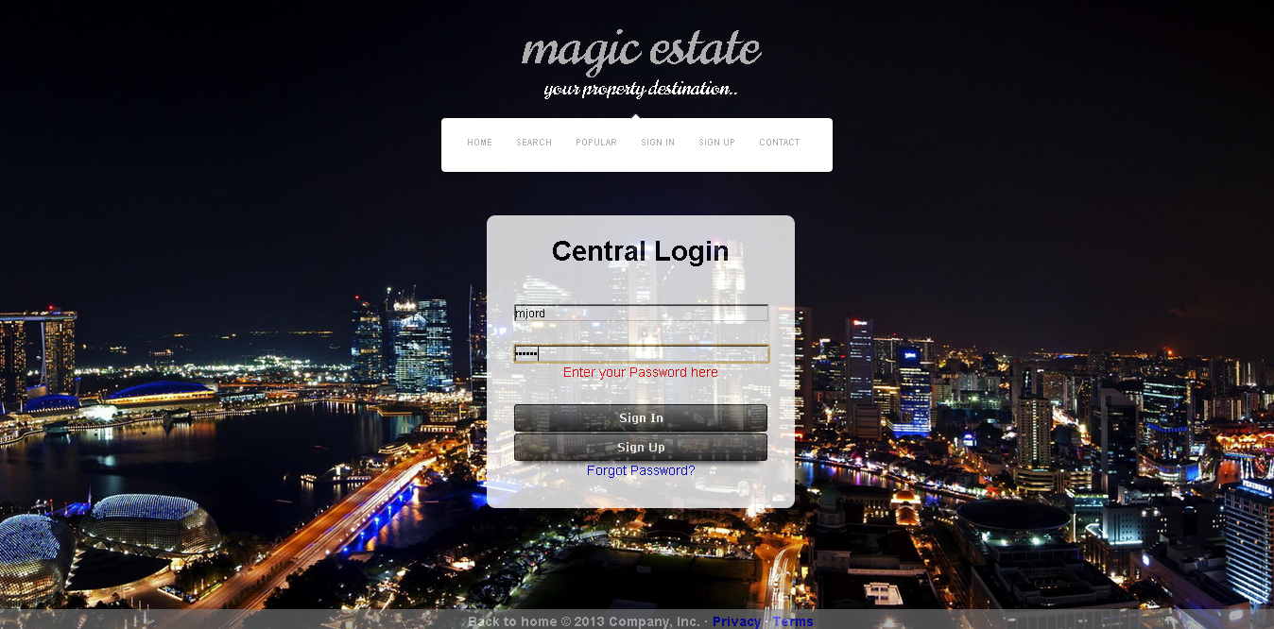

# Use Case #2: Sign-in User

## Description: After landing on home page user will sing in as admin. For this use case you can press the sign in button on the navigation bar and then sign in as registered user or as admin using following credentials.

USERNAME: MagicEstate

PASSWORD: \*\*\*\*\*\*

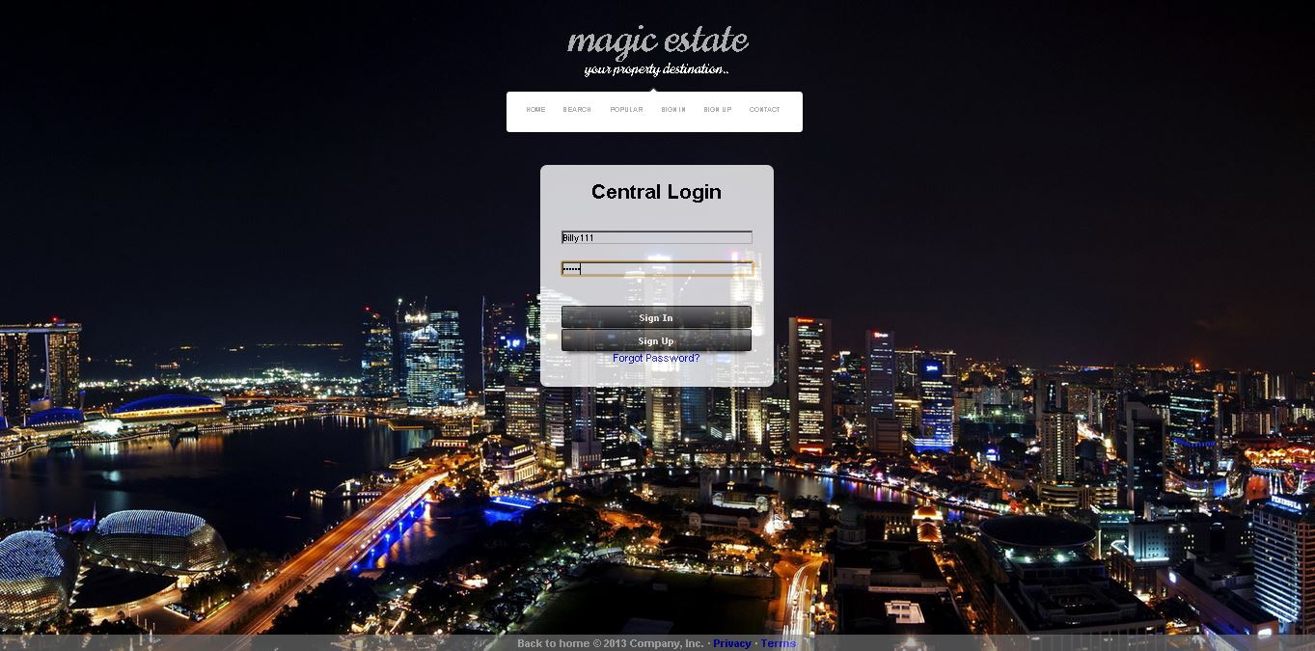

**Signed In:**

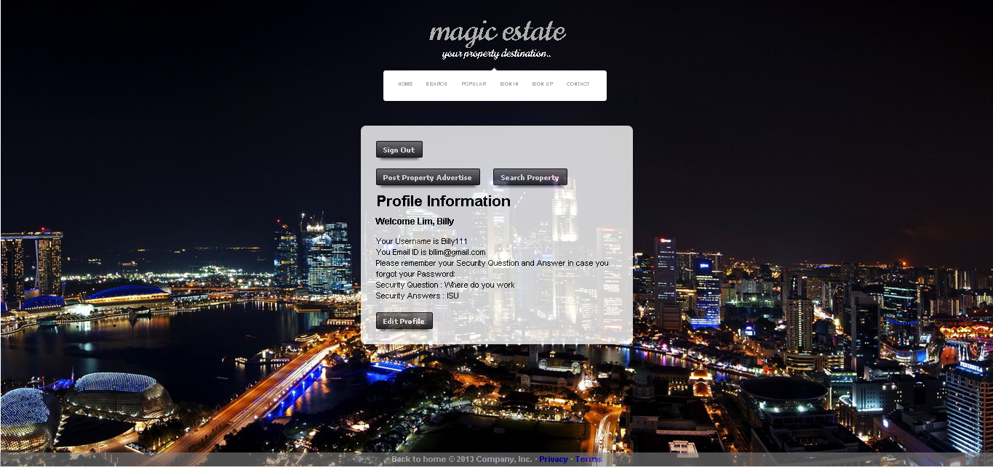

# Use Case #3: Search Land for Sale / Purchased

## After signing in just press the search ad button that will redirect you to the window in the screenshot. After landing on that window just fill out the specifications forms and press the search button. It you are signed as admin you can view, update and delete a property. If you are signed as normal user you can just view the property.

**Search Ad:**

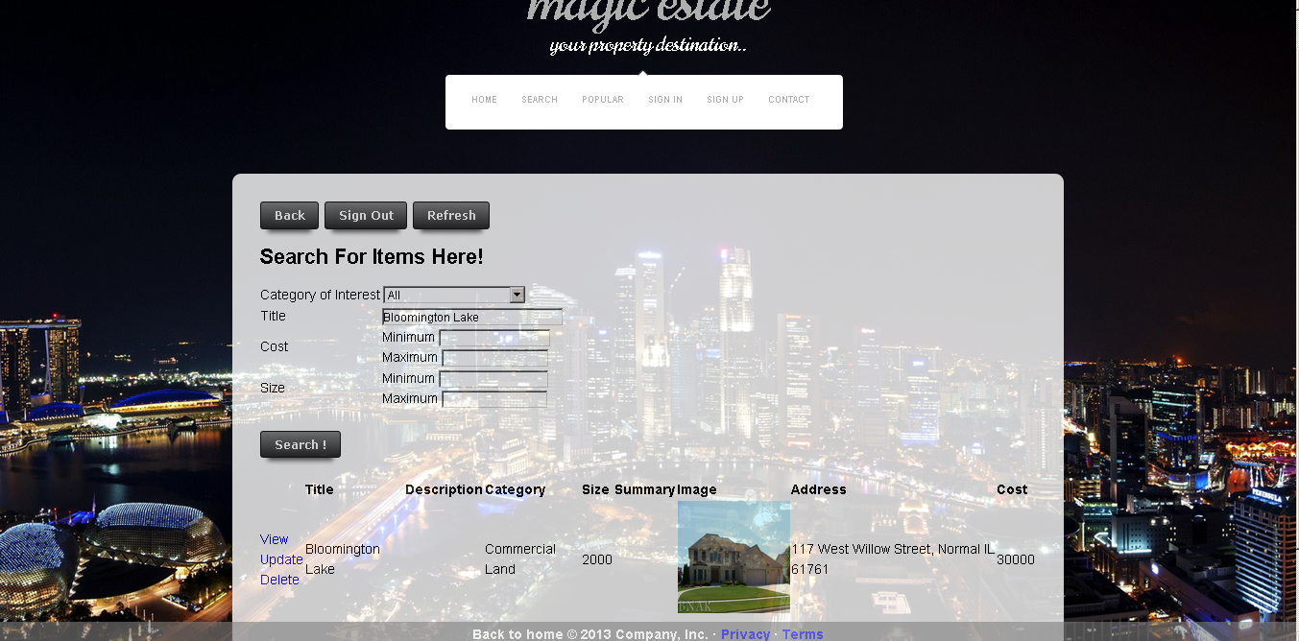

# Use Case #4: View Detailed Posting

## On clicking the View hyperlink the user go to the property info

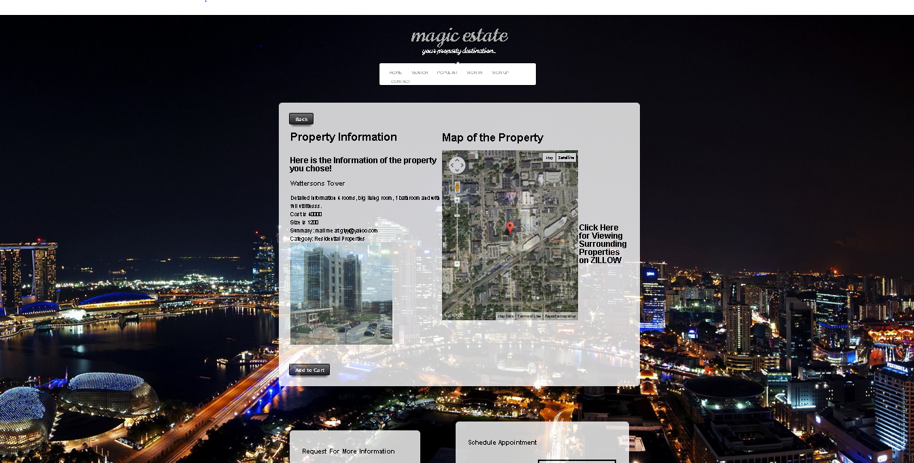

# Use Case #5: Add Property to Cart

## Just after viewing the property window you can press the add to cart property to add property to the cart.

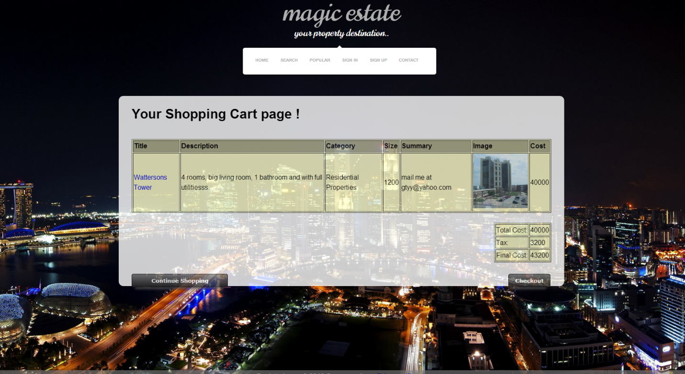

# Use Case #6: Checkout Cart

## After reaching the window of your cart you can continue shopping or do a checkout.

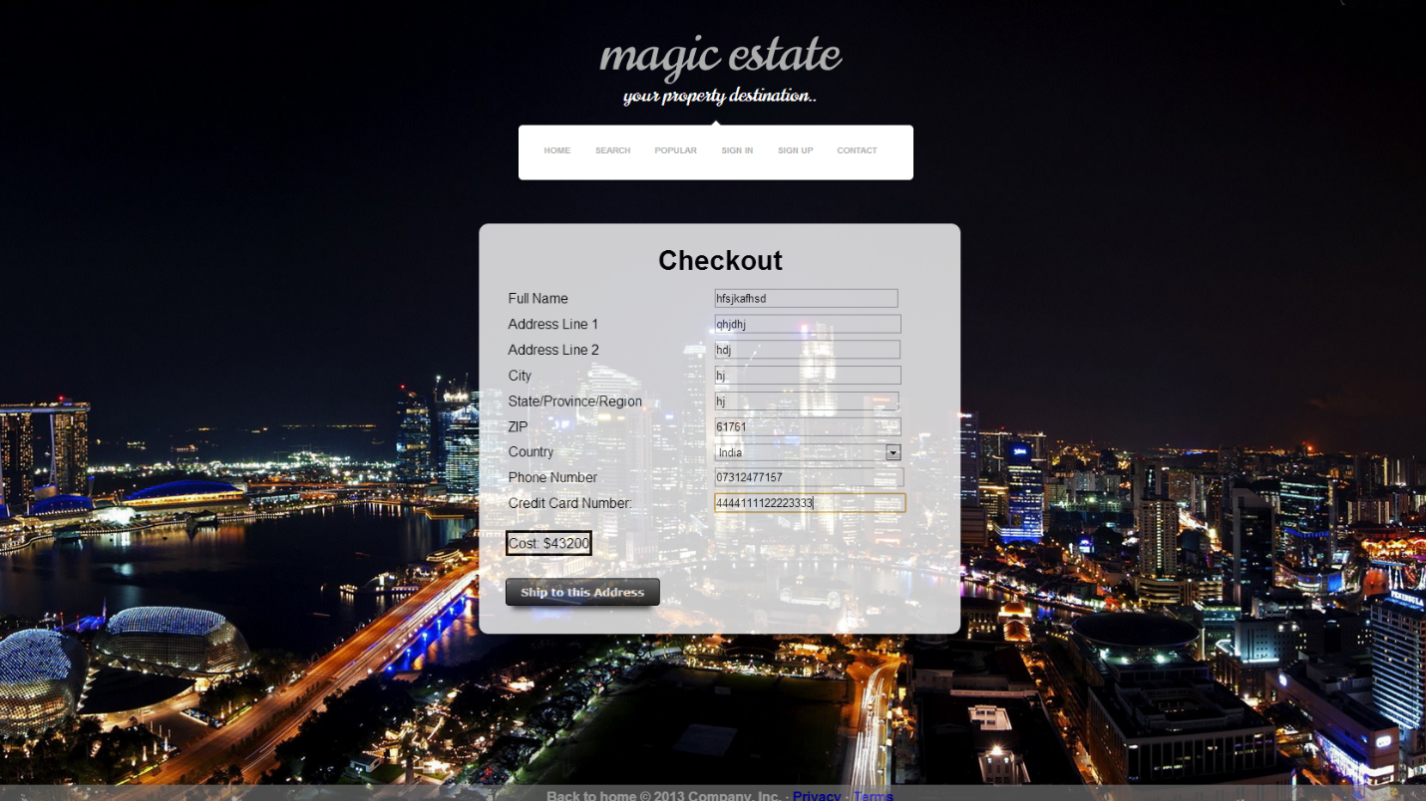

# Use Case #7: Upload Property Info (including image(s)) Admin only

## In this use case admin will post an advertisement about a property which is on Bloomington Lake. First user will hit the POSTAD button and then add the details about the property.

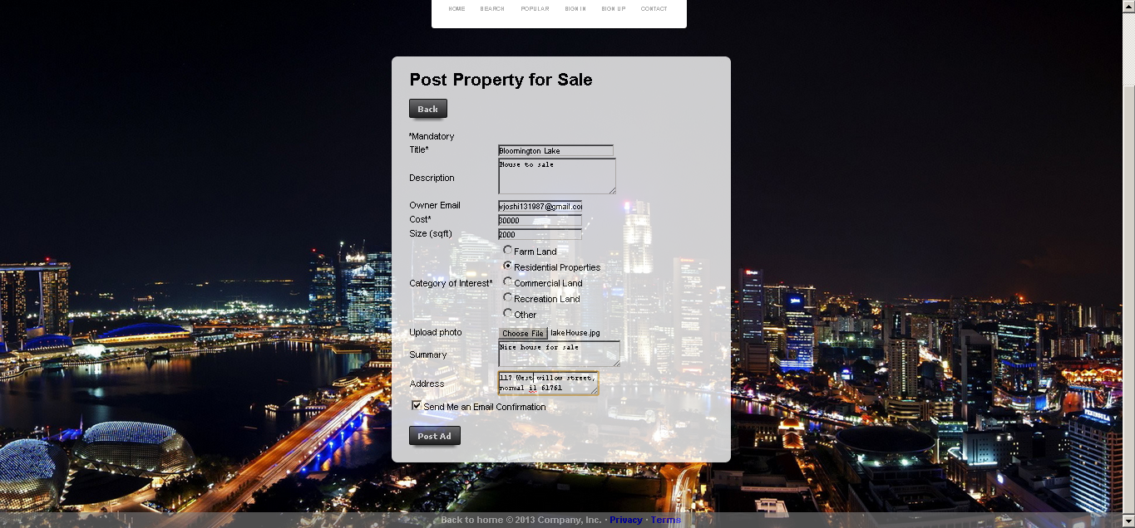

# Use Case #8: Schedule Appointment (with Email confirmation)

## On the view property info at the bottom right hand side there is window to schedule an appointment which sends email to the admin regarding particular meeting with the particular user.

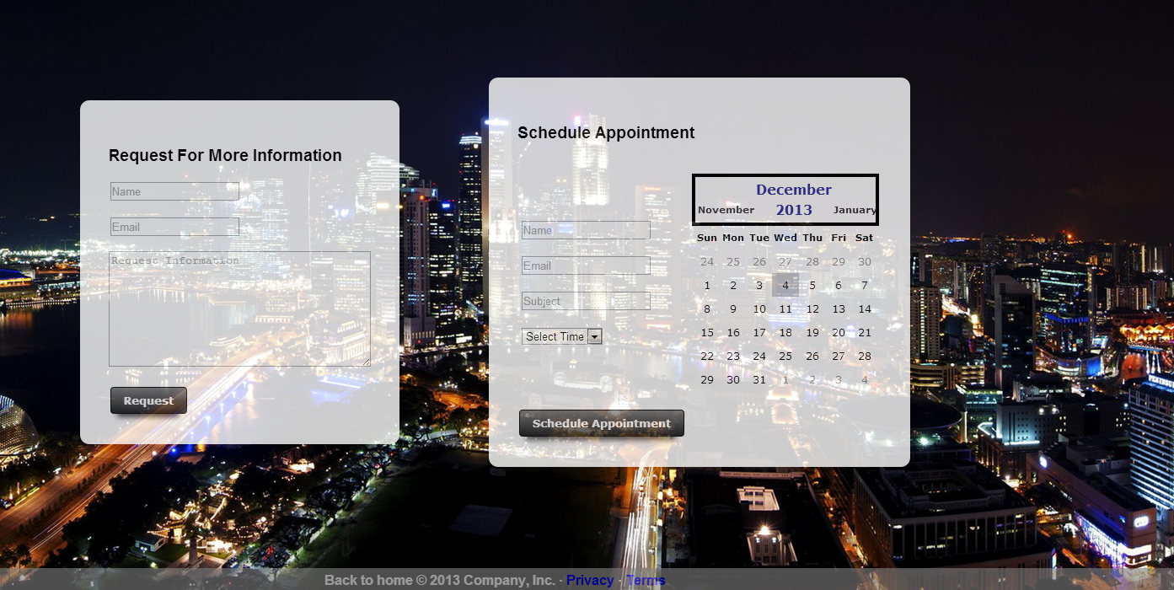

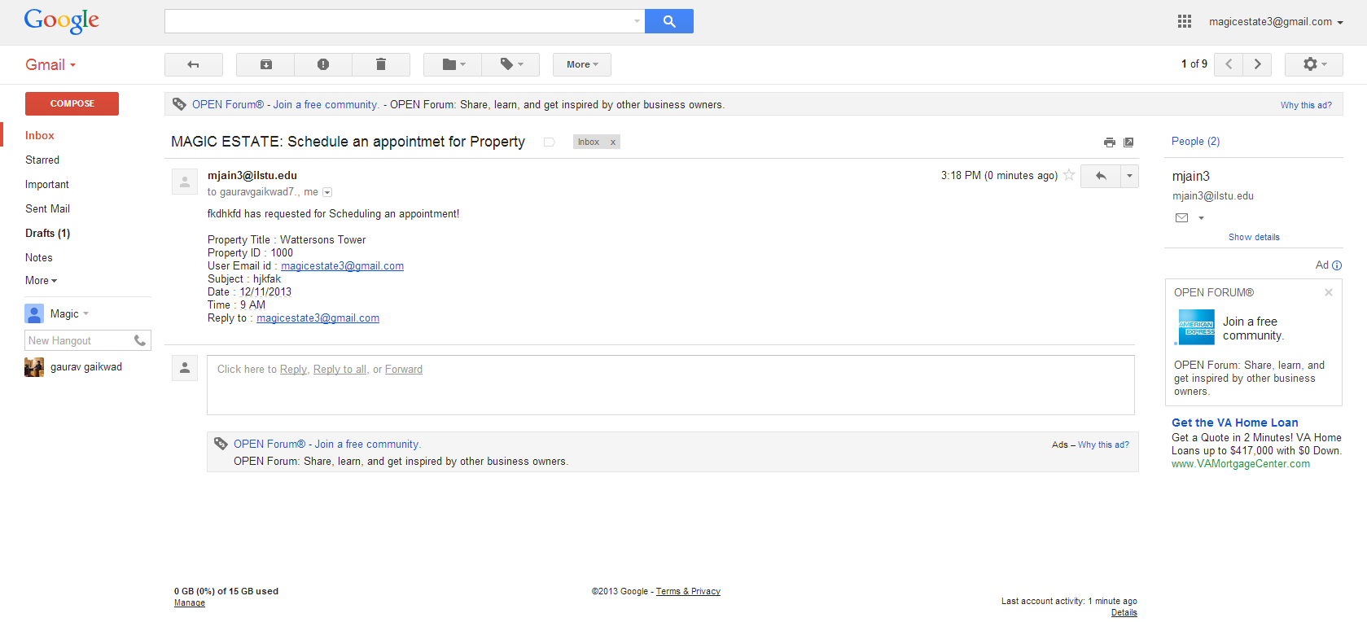

# Use Case #9: Request for More Information

## On the view property info at the bottom left hand side there is window to request for more info which sends email to the admin regarding user wants more info about the property



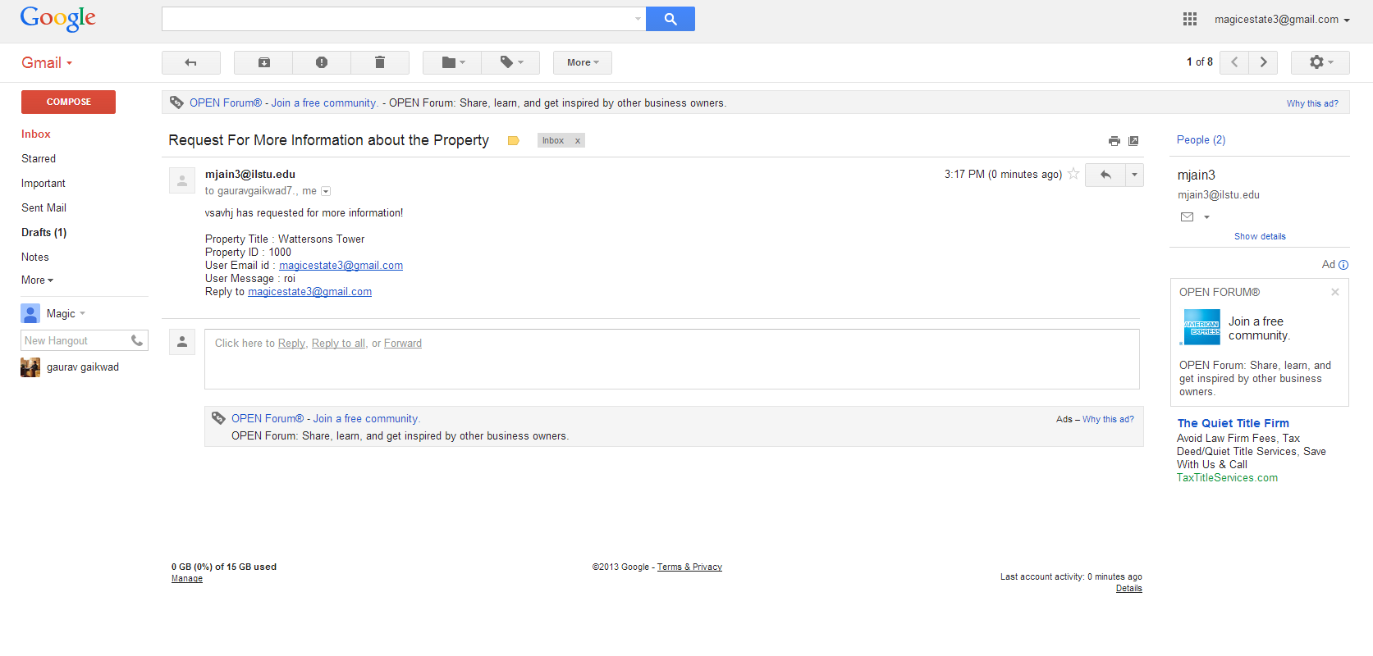

# Use Case #10: Highlight (Special Showcase) Property

## First user will land on the home page. And at home page there is an image slider which shows the featured property on clicking the images on slider the property info page is opened.

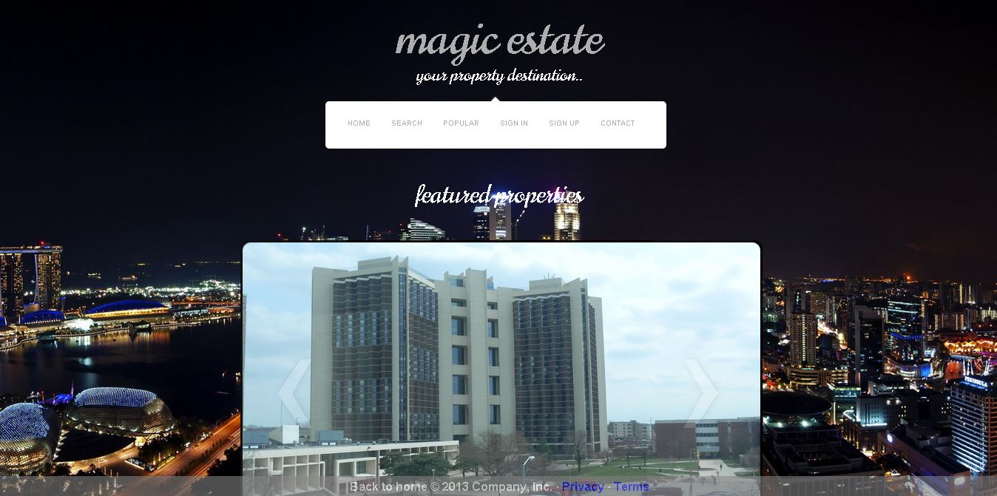



"Aiming Higher" Use Cases:

# Use Case #1: Show Surrounding Properties

## For this user case you have to first view the property info after landing on page there is a label saying click to view surrounding property on zillow. Just click on the label that redirects you to zillow ans shiws you the surrounding property.



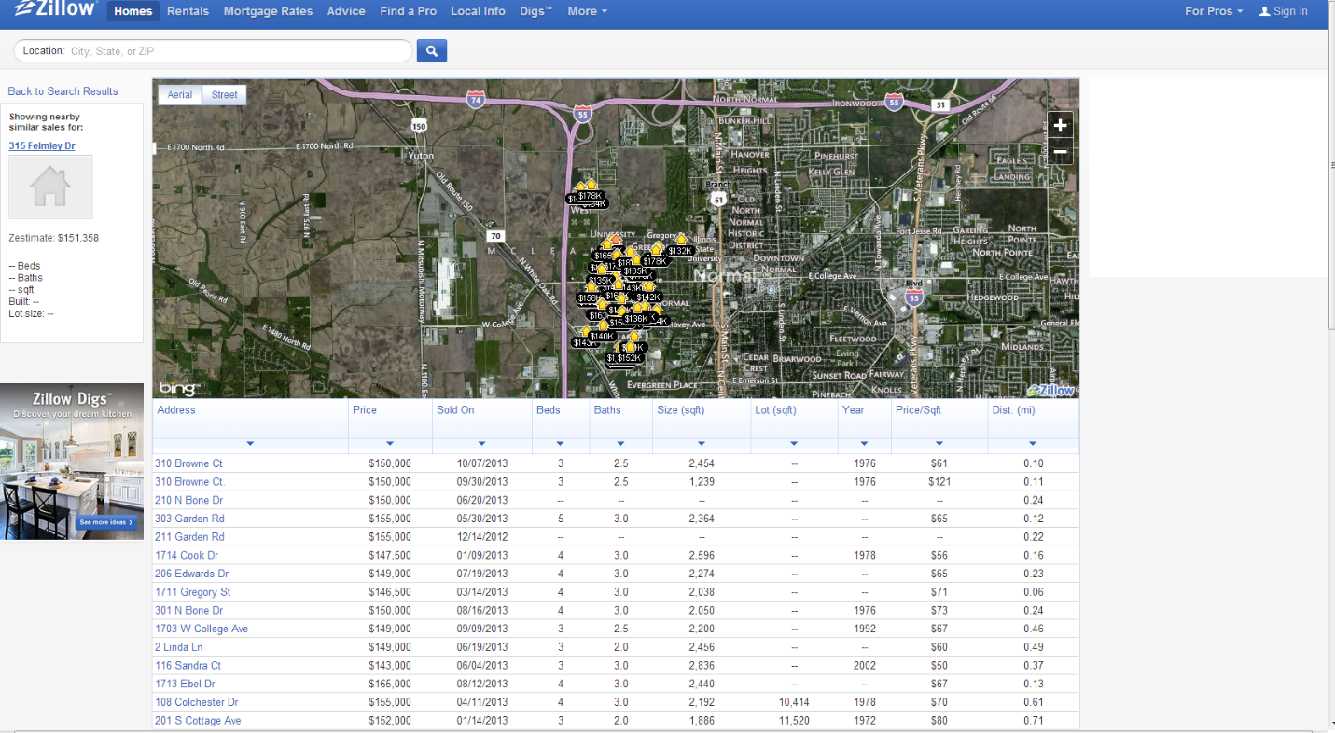

# Use Case #2: Show Map of Property (via Web services (e.g., Google Maps))

## On view property info page there is map of the property for which we used Google APIs.



# Use Case #3: Unsubscribe from Mailing

## With every email about magic estate we send unsubscribe link where you can unsubscribe them from e-mails.

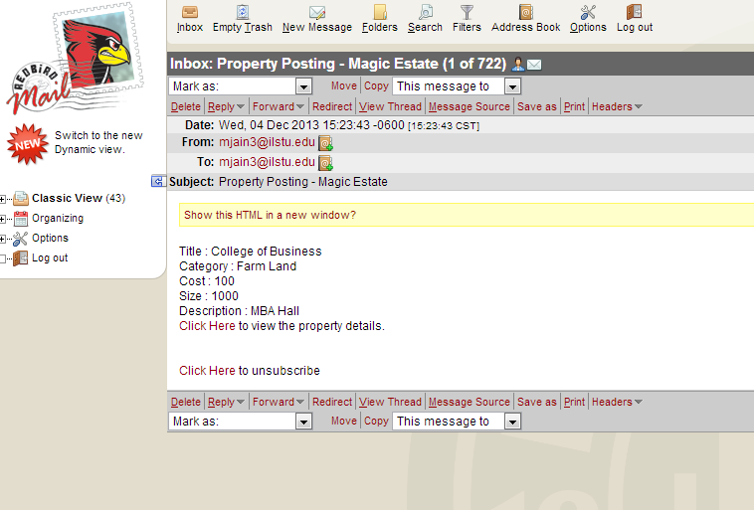

# Use Case #4: Update Property, Admin only

## When you search a property as admin on the search page there are three buttons for every property out of which clicking the update button will throw user to the property update page.



**Update Property Info:**

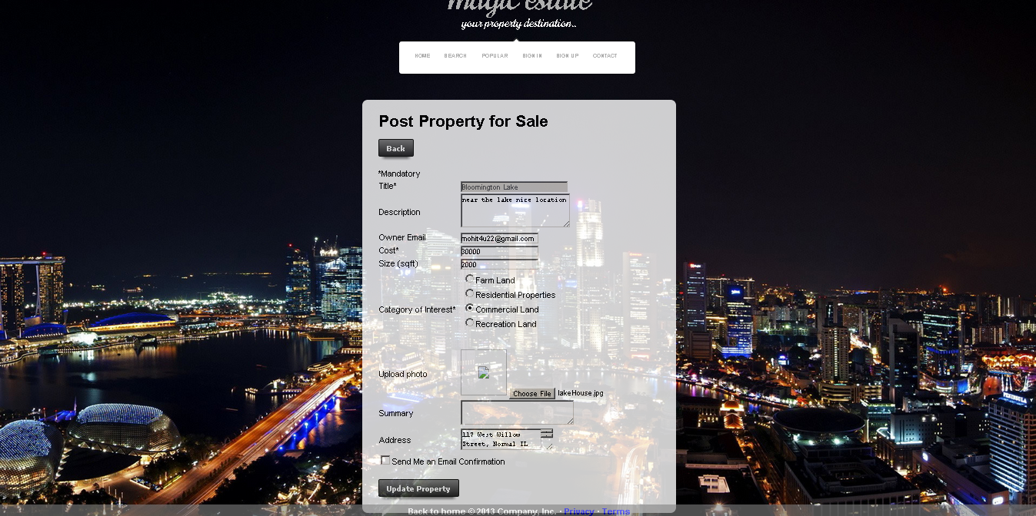

**Now we will sign out for the admin and now will sign up as a new user**

# Use Case #5: Report xxx (e.g., most viewed properties, most request-for-info properties, etc.)

## On the navigation bar there is popular button after clicking on it, the most viewed property pops up.

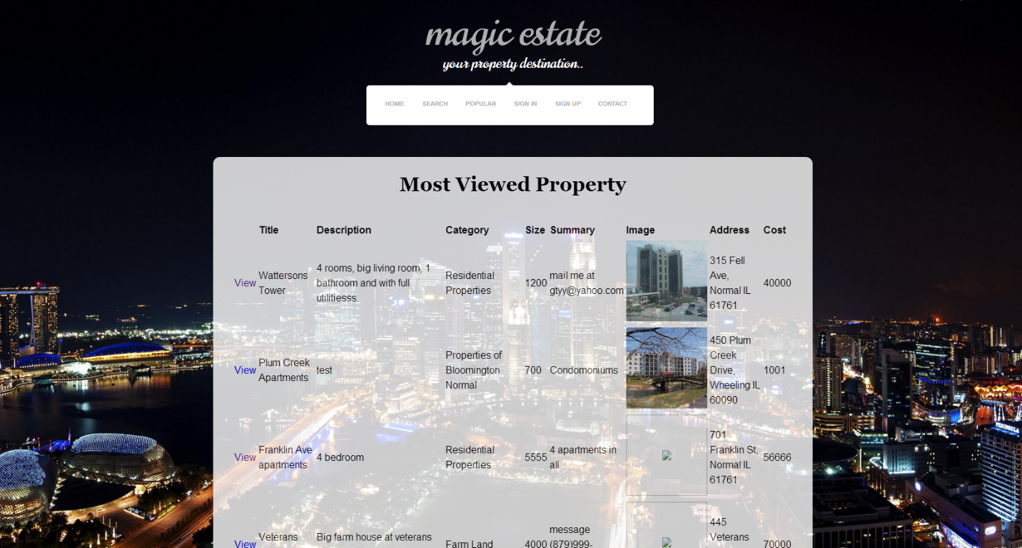

# Use Case #6: Retrieve lost password

## On sign in page there is a button for retrieve password which sends user an email with their password.

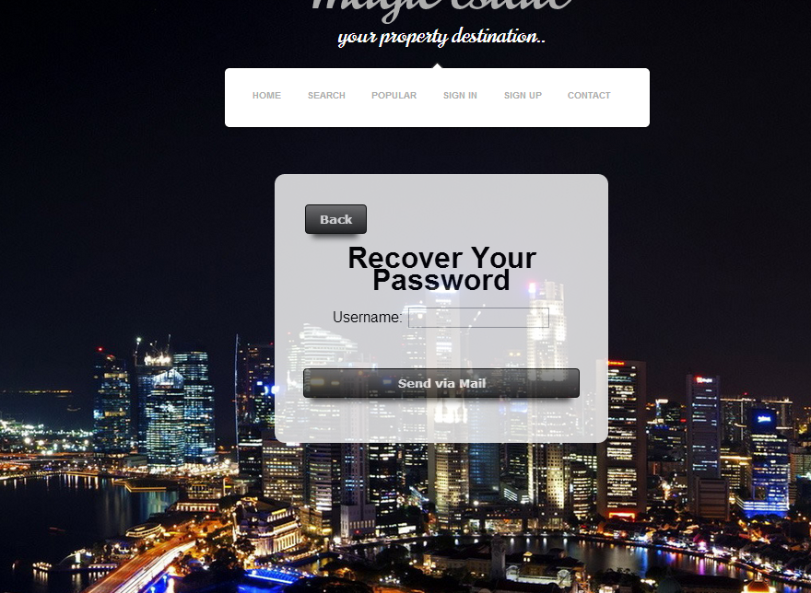

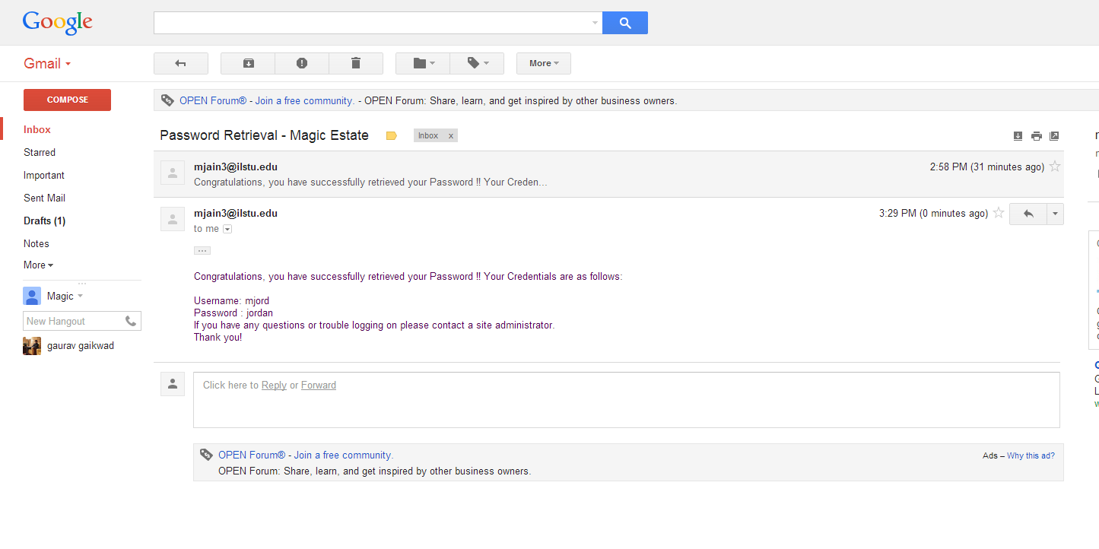

# Features to Add:

* Responsive design to website will make the website accessible to larger portion of mobile and other portable devices.
* Adding 'Yelp Web Service API' in website so that the customers intending to buy the property could get to know about hot places around the property.
* Implementing Ajax as much as possible throughout the website for simplicity and speed.
* Working more of accessibility for low vision, visually impaired and other disabled population which must get all the information.